Q1) 0xfffef0e0

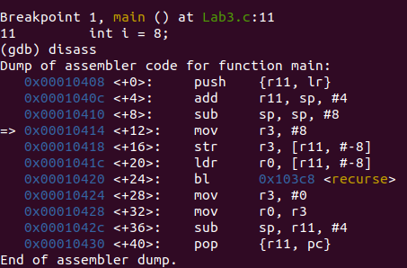

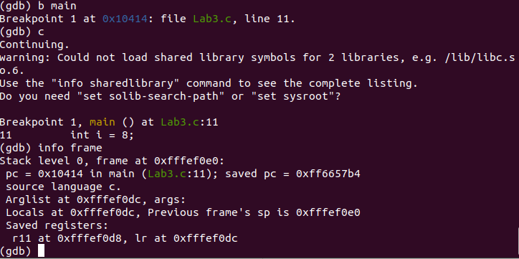

Q2)
lr 0xff6657b4 -10070092
lr 0x10424 66596
lr 0x103fc 66556

We are using Stack to store lr values in case of Recursion.
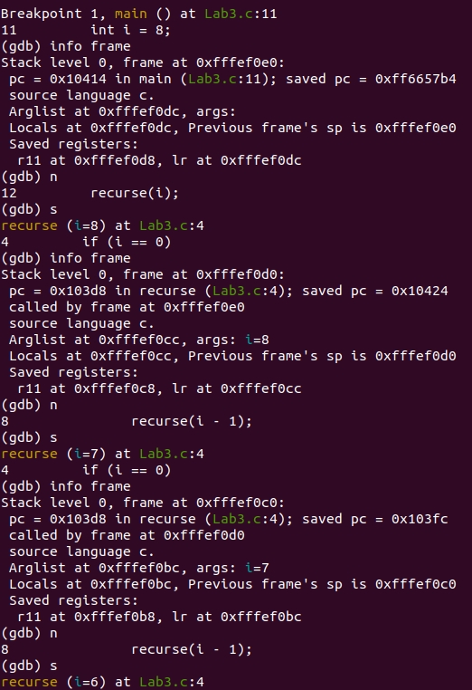

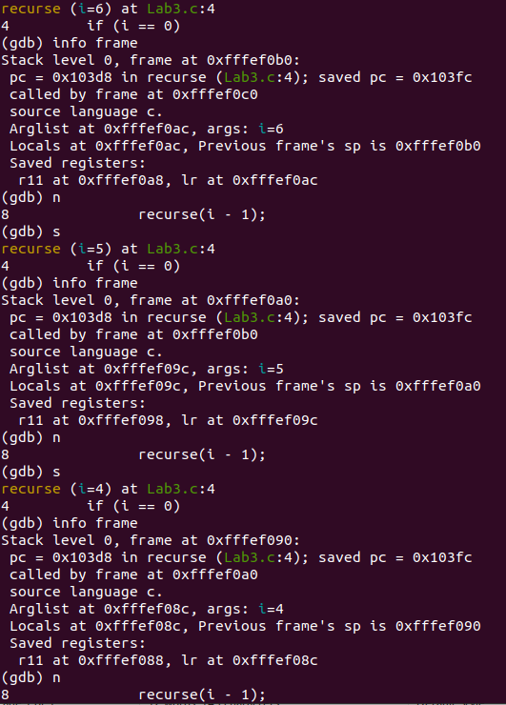

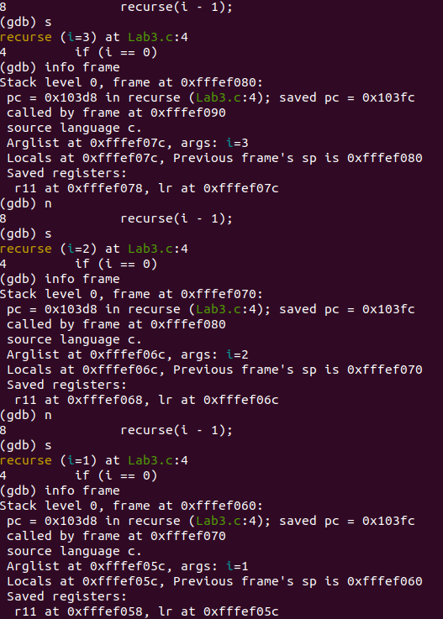

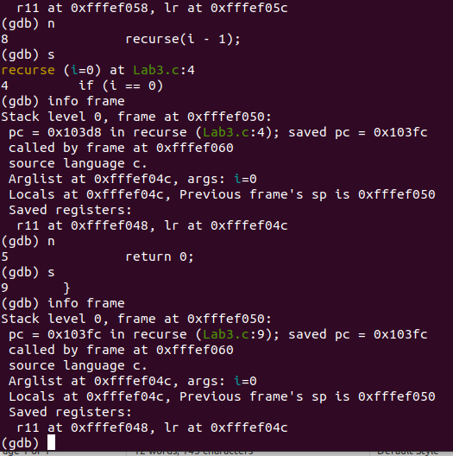

Q3)
#include <stdio.h>

int main() {
int i = 8;
for (i; i != 0; i--);
return 0;
}

Implemeting Loops instead of Recursion will make sure that it can run without the use of stack, at the same time the number of function calls are as much as possible.

